Project Title: Tata Steel Machine Failure Prediction
Project Type: Classification

Business Context

In the manufacturing sector, maintaining the efficiency and reliability of machinery is critical to achieving optimal production quality and minimizing downtime. TATA Steel, a leader in the steel manufacturing industry, is constantly looking to improve its production processes by leveraging advanced data analytics and machine learning techniques. The ability to predict and prevent machine failures is crucial for minimizing production losses, reducing maintenance costs, and ensuring product quality.

The dataset provided in this project represents various operational parameters and failure types of machinery used in steel production. The data is synthetically generated based on real-world scenarios, allowing us to explore different machine learning techniques to predict potential failures. By analyzing this data, TATA Steel aims to develop predictive models that can anticipate machine failures before they occur, thus enabling proactive maintenance and improved operational efficiency.

Dataset Description

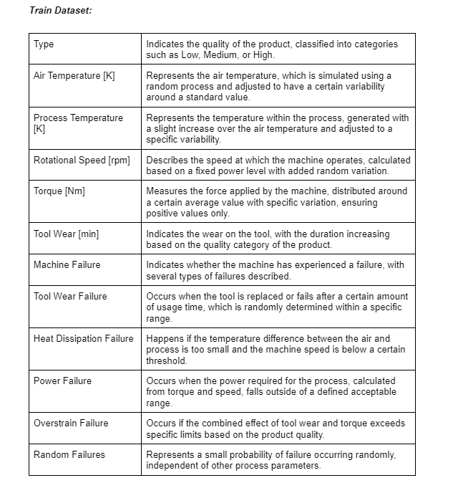

- Exploratory Data Analysis (EDA) Insights & Visuals
- There are 136429 rows and 14 columns in the data set. This is the first five rows in the dataset.
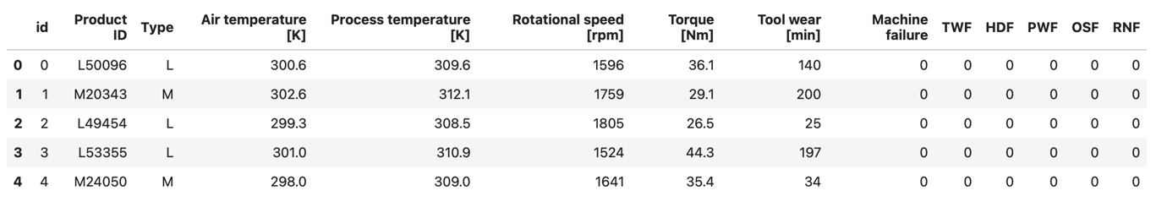
- There is no missing data

- There is no duplicate data

- Data type
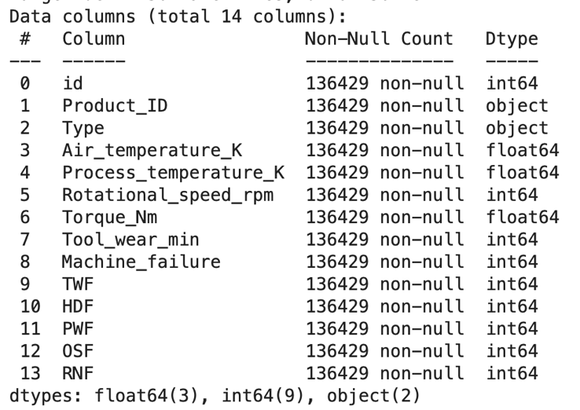

- Statistical summary for numerical data
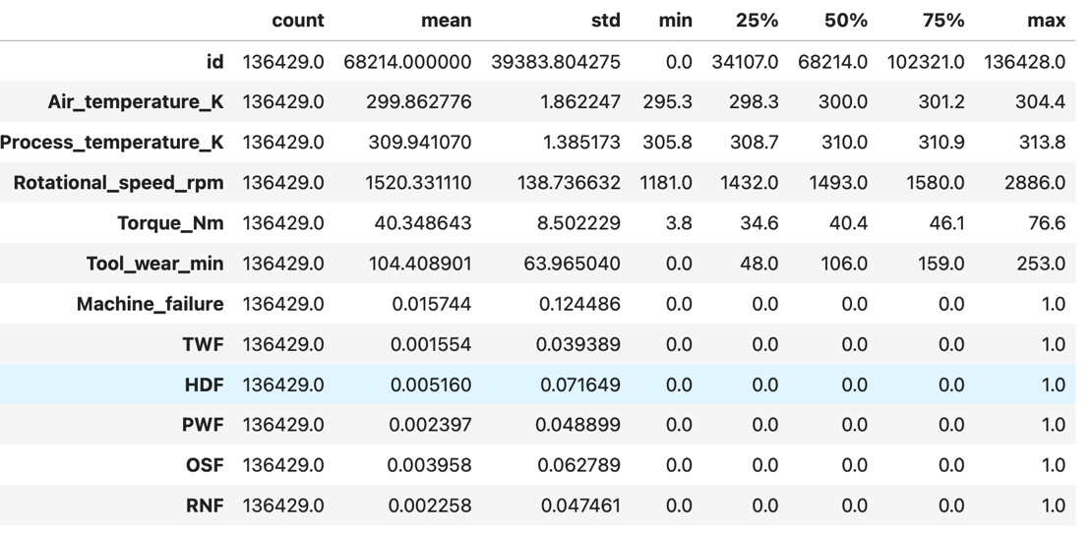

- Statistical summary for categorical data
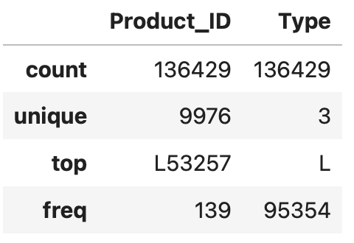
- Count plot of machine failure
Not failed: 134281, Failed: 2148 (1.57%). So, the dataset is highly imbalanced in the view of machine failure.
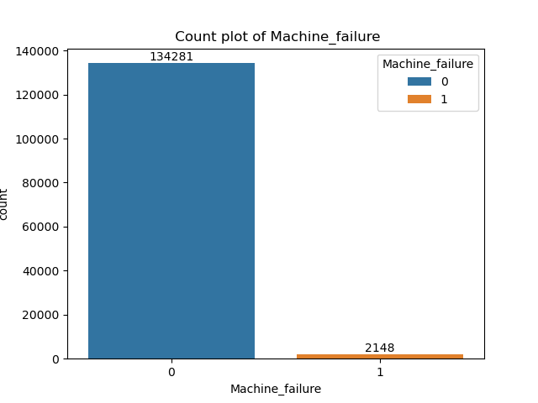
- Count plot of "Type"
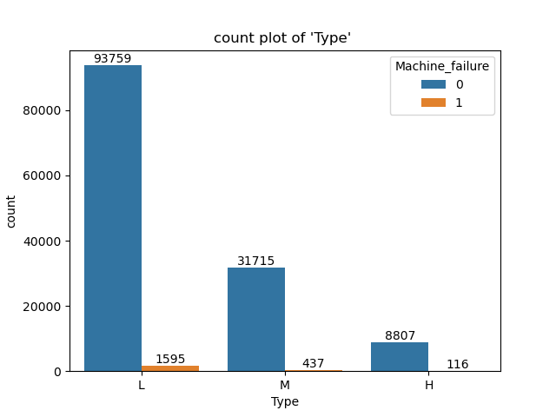
Most of the data are belonging to the “ L” category compared to others two categories.

9. Count plot of HDF, TWF, PWF, OSF
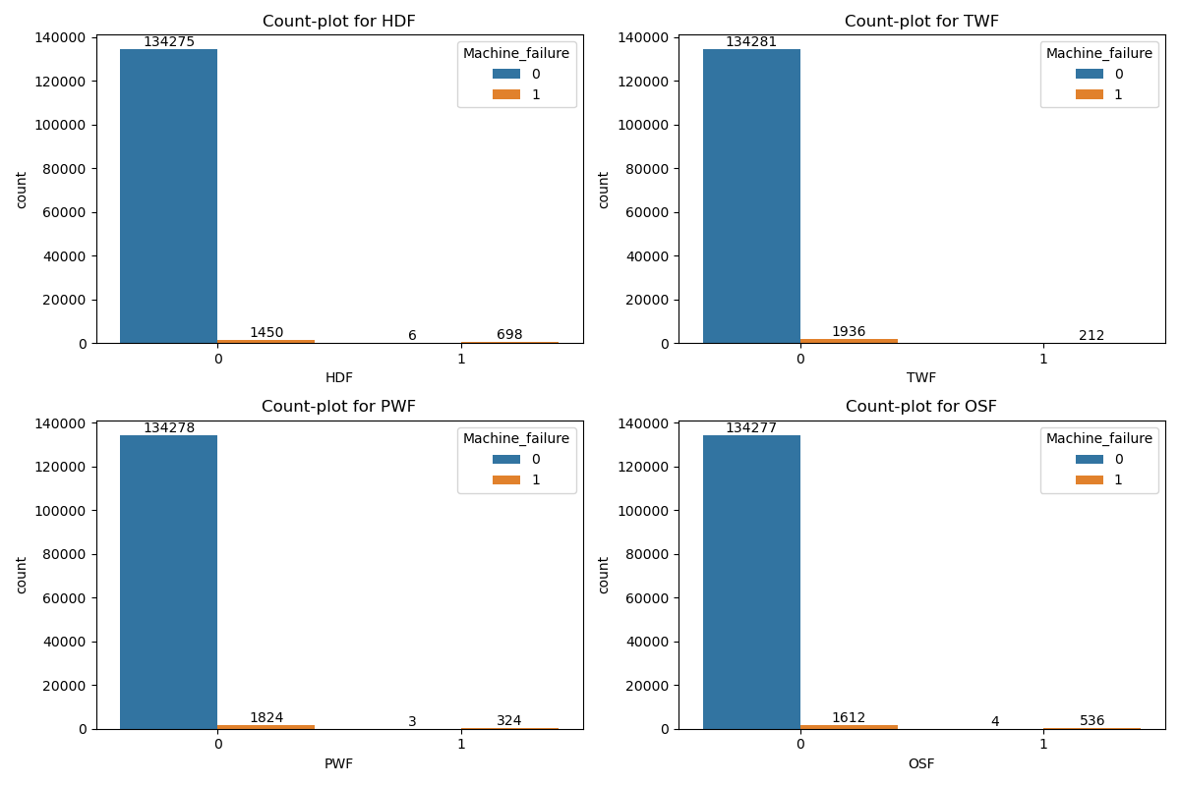
HDF, PWF, and OSF show similar patterns in their distribution. In these failure types, there are instances where the machine does not fail even though the failure condition is triggered.
10. Histogram plot of Air Temp and Torque
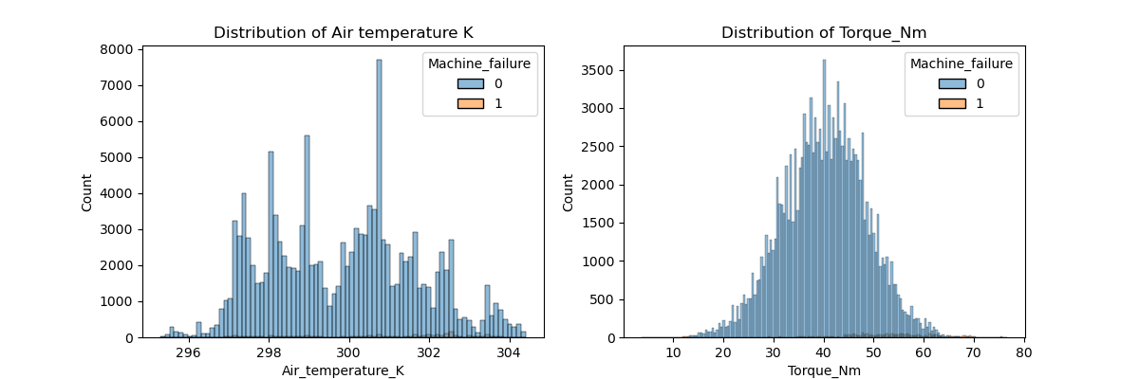
The air-temperature histogram shows several peaks, indicating that certain temperature ranges occur more frequently in the dataset. In the case of torque, it is showing gaussian distribution around the mean value (~40).
11. Scatter plot between Air_temperature and Process_temperature & Rotational_speed and Torque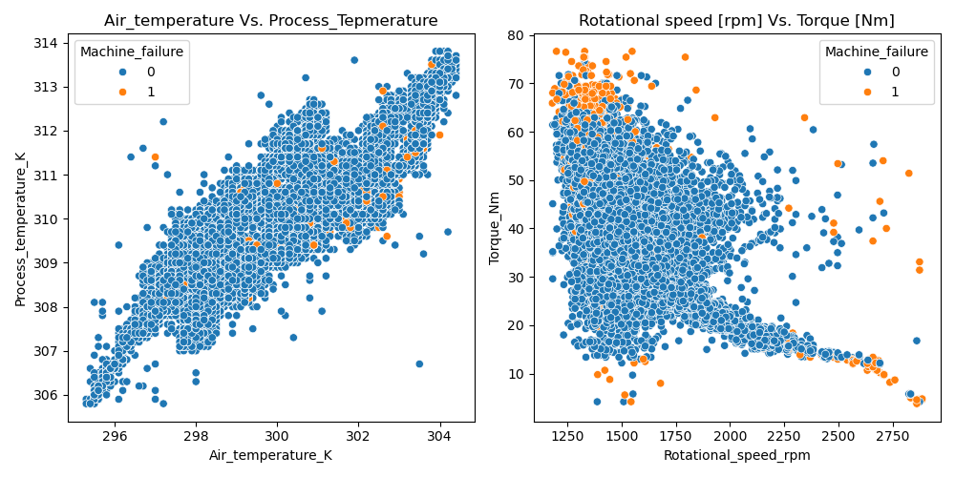
Air temperature and process temperature exhibit a strong linear relationship, indicating that process temperature increases with air temperature. In the case of rotational speed and torque, a linear relationship is observed for higher values of rotational speed and lower torque, but in other regions no definite relationship is observed.

12. Pair plot among the "Tool wear [min]","Rotational speed [rpm]","Torque [Nm]","Air temperature [K]","Process temperature [K]"
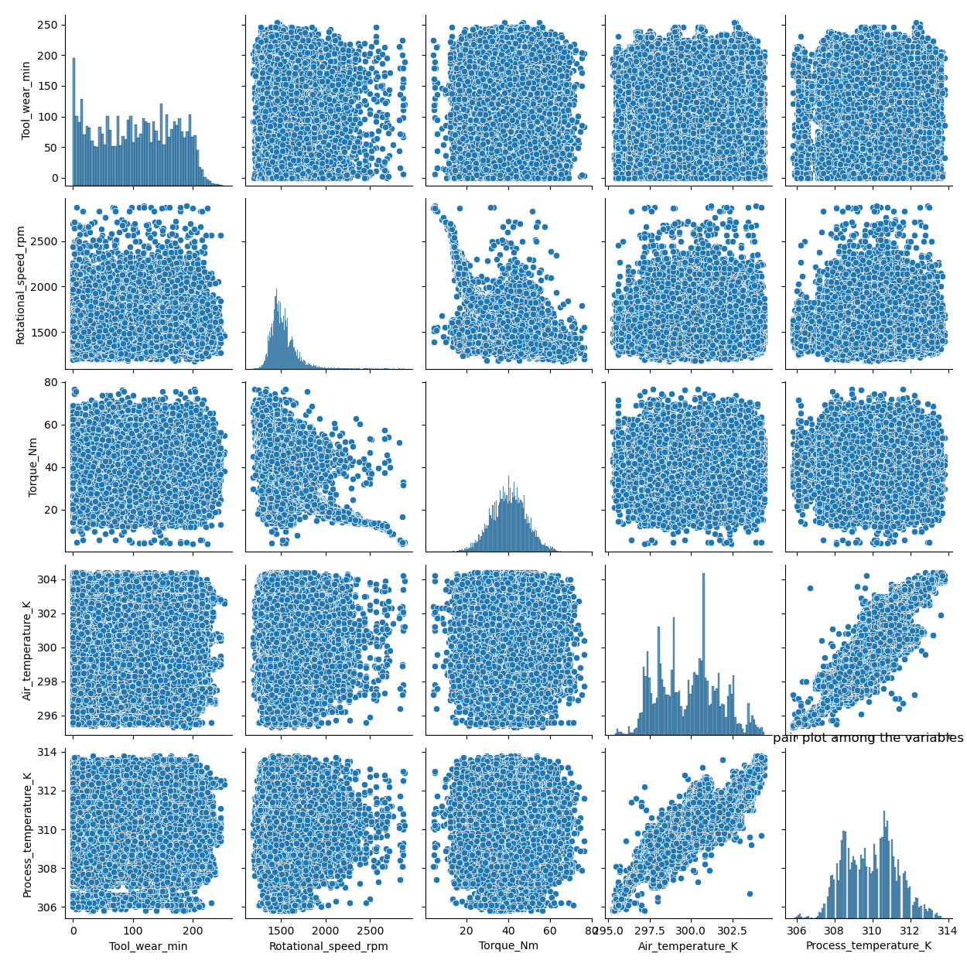

All the plots appear similar except for the two discussed above. The remaining feature pairs appear to be approximately uniformly distributed, suggesting weak or no strong relationships among them.

13. Correlation plot among the features
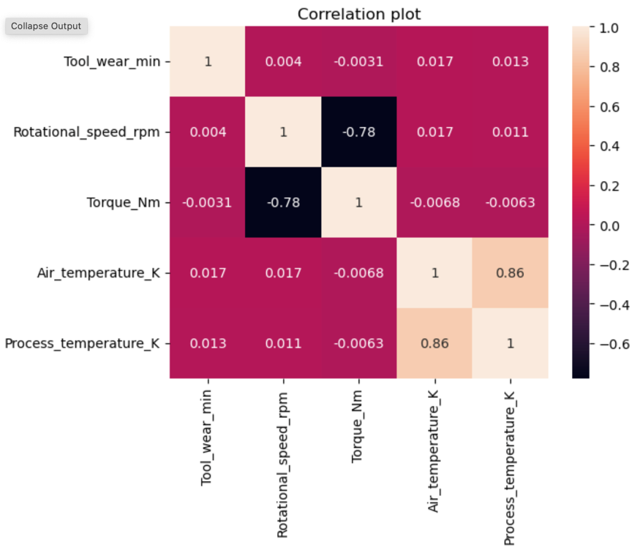
The plot shows that rotational speed and torque are highly negatively correlated, whereas air temperature and process temperature are highly positively correlated.

14. Checking the outliers using box-plot
Outliers are (>Q3+1.5*IQR or <Q1- 1.5*IQR).
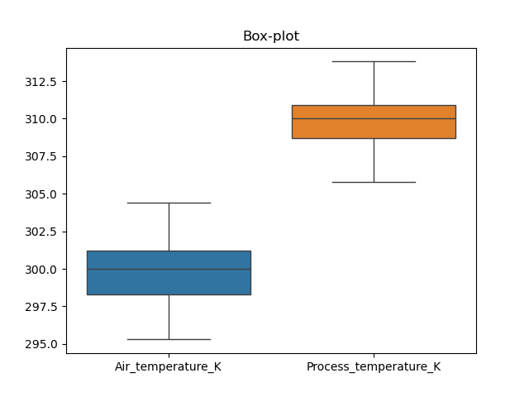
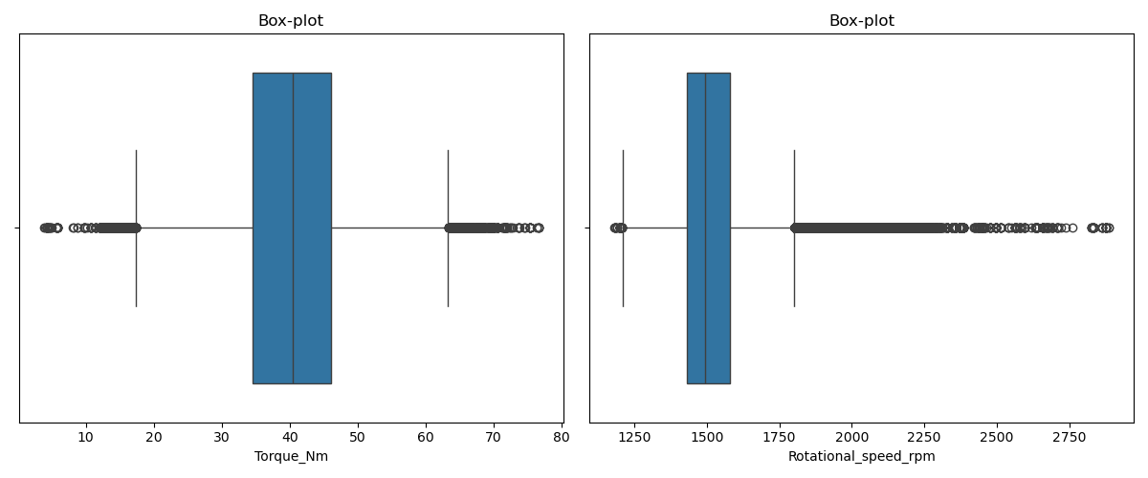
15. No. of Outliers in Torque is (1060)

Machine_failure: 342 (2148)
Machine NOT failure: 718 (134281)

Log transformation: outliers (2594)

Box-Cox transformation: outliers (1013)

After applying log transformation and Box–Cox transformation, the outliers could not be effectively controlled. Therefore, they will be retained. Additionally, since the dataset is imbalanced, these outliers may carry important information and should not be removed.

- Model Building Process:
Pre-processing :
- Removed id and Product_Id from the dataset.
- One-hot encoding: Applied one-hot encoding to the “Type” feature to convert categorical values(H, M and L) into a numerical format suitable for model training.
- Feature selection: Feature selection was performed using a Random Forest classifier to identify the most relevant predictors.

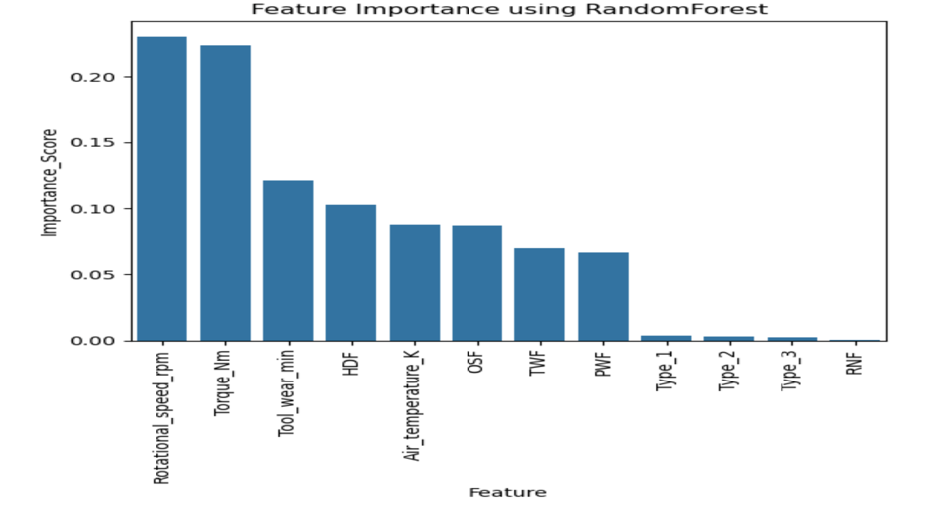
Therefore, we have considered features up to PWF as relevant predictors for the model.

(d)Train–test splitting: Since the dataset is highly imbalanced (134,281 : 2,148), we performed a train–test split using stratification to preserve the class distribution in both sets.
(e) Oversampling: Due to class imbalance, oversampling was applied. It was observed that random oversampling performed better than SMOTE in this case.

Train model: (i) DecisionTreeClassifier (criterion="gini", class_weight="balanced", random_state=42) with the parameters: "params": {max_depth": [10, 20], 'min_samples_split': [5,7], "min_samples_leaf": [ 3, 5]}
(ii) RandomForestClassifier ( max_samples=0.8, random_state=42, bootstrap=True): with the parameters "params": "n_estimators": [100, 200], "max_depth": [10, 20], 'min_samples_split': [5,7], "min_samples_leaf": [ 3, 5]}
(iii) GradientBoostingClassifier(subsample=0.8, learning_rate=0.01, random_state=42): with the parameters {"params": 'n_estimators': [100,200], 'max_depth': [3, 5]}
(iv) XGBClassifier(learning_rate=0.01, subsample=0.8, random_state=42, eval_metric='auc'): with the parameters: "params": { 'n_estimators': [100,200], 'max_depth': [3,5]}
(v) LGBMClassifier(learning_rate=0.01, subsample=0.8, force_row_wise=True, verbose =-1, random_state=42): with the parameters: { "params": {'n_estimators': [100,200], 'max_depth': [ 5,8], 'num_leaves': [20, 40]}

The model was trained using stratified K-fold cross-validation, and the best estimators were selected and stored. Given the imbalanced nature of the dataset, the F1-score (scoring='f1') was used as the evaluation metric for hyperparameter tuning.

- Model Evaluation: It was conducted on the test dataset using the following performance metrics: accuracy, precision, recall, F1-score, and ROC-AUC.
Evaluation Results:
{'DecisionTree': {'accuracy': 0.97, 'precision': 0.35, 'recall': 0.8, 'f1_score': 0.49, 'roc_auc': 0.92},
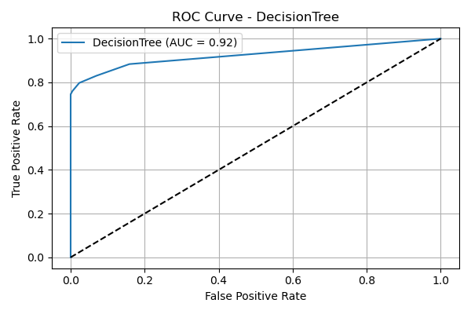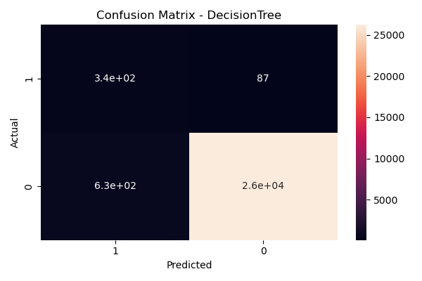

'GradientBoostingClassifier': {'accuracy': 0.96, 'precision': 0.25, 'recall': 0.86, 'f1_score': 0.38, 'roc_auc':0. 95},

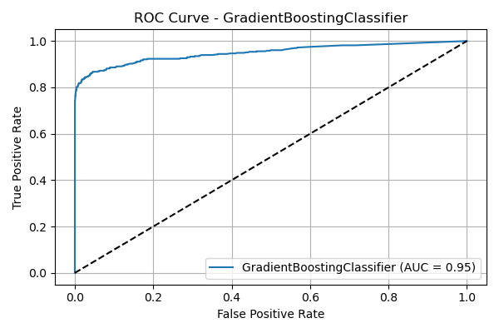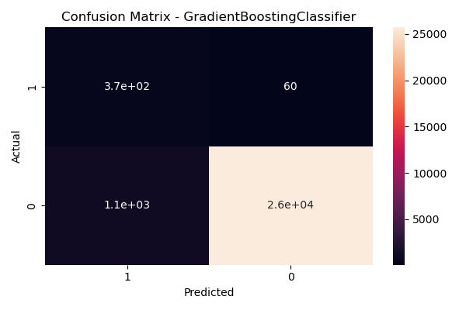

'RandomForest': {'accuracy': 0.99, 'precision': 0.86, 'recall': 0.8, 'f1_score': 0.83, 'roc_auc': 0.94},

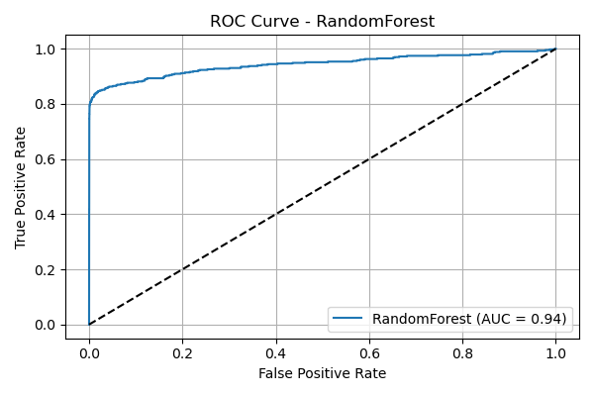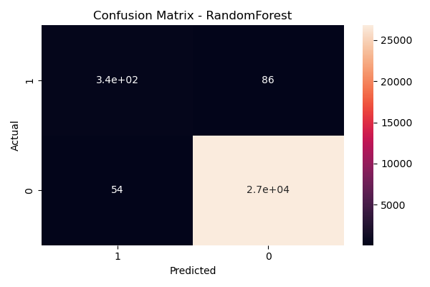

'LGBMClassifier': {'accuracy': 0.97, 'precision': 0.3, 'recall': 0.85, 'f1_score': 0.44, 'roc_auc': 0.95},
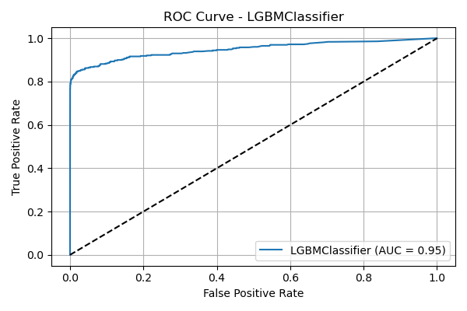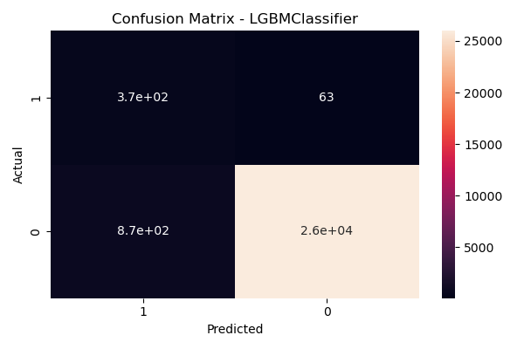

'XGBoost': {'accuracy': 0.96, 'precision': 0.26, 'recall': 0.86, 'f1_score': 0.4, 'roc_auc': 0.95}}
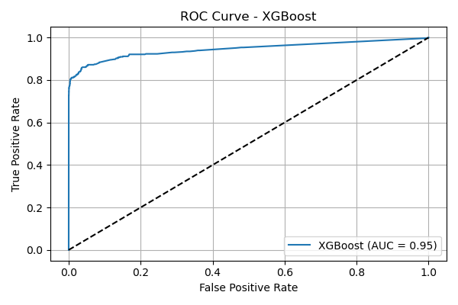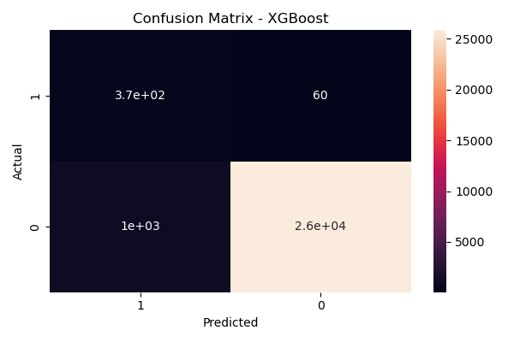

Summary:
- Machine failures are rare (~1.57%) but highly impactful, so models should avoid missing failures.
- Key factors driving failures include torque, rotational speed, tool wear, temperature, and specific failure types (HDF, TWF, PWF).
- Due to the highly imbalanced nature of the dataset, the F1-score is used as the primary evaluation metric. Based on this criterion, the Random Forest model achieves an F1-score of 83%, indicating a strong balance between precision and recall, and making it well-suited for real-world deployment.
- Predictive maintenance using AI helps detect issues early, reduce downtime, improve efficiency, and lower costs.

Best Model:
RandomForestClassifier(max_depth=20, max_samples=0.8, min_samples_leaf=3,
min_samples_split=5, random_state=42)

- Deployment Summary
https://tata-steel-machine-failure-prediction.streamlit.app/
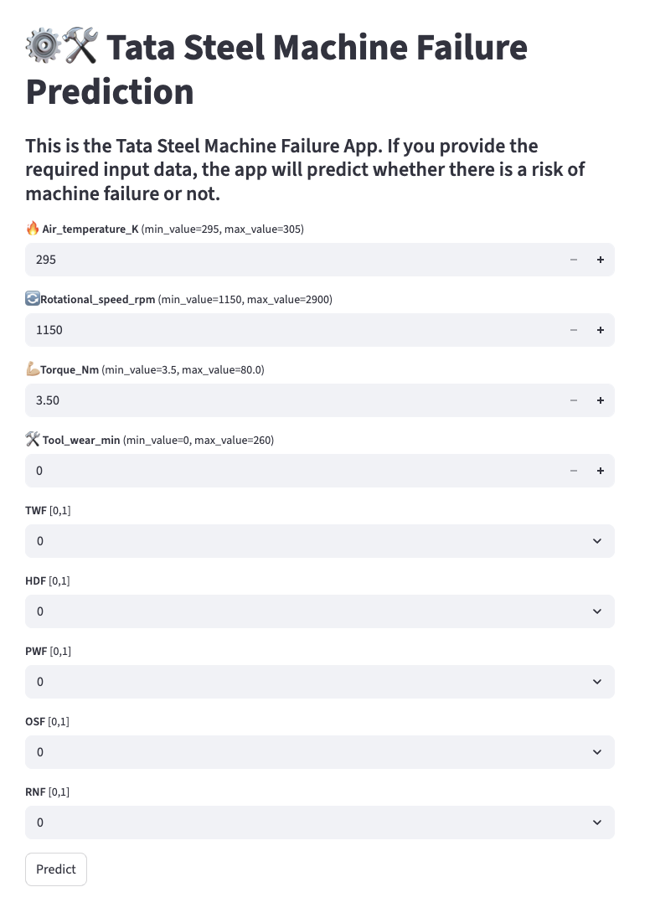
- Video Link
- GitHub / Colab Notebook Link

